Functionalities Required for HHT-Online Purpose
[HHT Operation Manual]



Functionalities Required for Modem operations in the HHT:

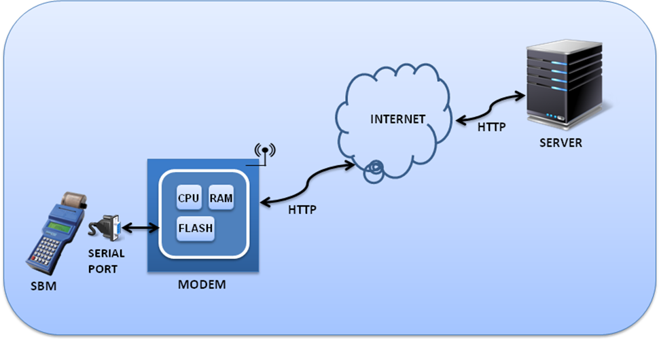
Figure 1

- Data Sending to the server
After completing the transactions (Billing or Collection) data is to be pushed to modem and get the necessary response as ACK or NCK.
- Modem will give ACK when the available data is written.
- Modem will give NCK when the data is not written in it.
Description: Modem has to store the data (Which came from SBM through serial port by this command) and try for the GPRS connection. Whenever the GRPRS is available it will try to send the data to Server through http.
If it fails to send, it stores the data in the back up file. In the backend, modem will try another time for GPRS availability to send the data to server. Data will be stored in the file in FIFO model (First in First Out).
- Read health status
This will give the health status of the HHT which includes Number of bytes to be send to server, Signal Strength of the SIM, SIM availability, GPRS Status and the Server Connectivity Status.
- Read Record from Server with Consumer number
When data for particular consumer is required, the client sends the consumer number to the modem to get the appropriate details.
Description: This is On Demand Mode means whatever may be the modem state, whenever modem receives this command from SBM instantly it will contact the server with Consumer ID, and will get the response record from the server and the same will be send to SBM through serial port
- Read URL and APN
To read the URL and APN which is pre-configured in the device, it consists of 80 characters URL and 30 characters APN.
- Setting URL
Known as web address, particularly when used with HTTP), is a specific character string that constitutes a reference to a resource.
User or operator can check the desired URL to which the data to be transferred.
- Setting APN
An Access Point Name (APN) is the name of a gateway between a GPRS, 3G or 4G mobile networks and another computer network, frequently the public Internet.
User or operator can select the APN and must be configured with provided SIM. (Example: Airtel, BSNL, TATA DOCOMO, IDEA.)
- Clearing Modem
To clear the modem data when serial data upload successfully done through serial cable. So that after this step modem will be reinitialized.
- To set DATE and TIME
To set the current time and date to modem this option is used, default format is DDMMYYHHMMSS.
- Command Mode
If client requires any information about the modem then he will send the modem commands to get the appropriate information.

- Open CPU Firm Update Version
This mode is used to check the current firm ware version of any particular modem.
- AT Mode
Whenever this command is received, modem will send the AT command to internal modem and catch the response to send back to SBM (spot billing machine).

Code:

0x02 --- Start of text
0x03 --- End of text
Data Command:
0x21 --- Setting url and apnserver
0x22 --- To Send Data To Server
0x23 --- Read health status (len,SignalStrength,simavailable,gprs,http connect status and T(if it is Telit Modem).
0x24 --- Read URL (80 char) and APNSERVER (30 char) in unit (HttpUrl,ApnServer)
0x25 --- Delete files
//0x26 --- Query for getting data from server (not using read a query from uart and sends to server and get data from server and writes to a file)
//0x27 --- read downloaded data from unit //not using as of now hard coded to some txt file
0x28 --- Read Record from Server with Service No.
0x29 --- Get rtc date time from unit and sets.
//0x2A --- Send Sms (Mob.No.,Data).{optional not using}
//0x2B --- Read Received Sms.{optional not using}
0x2C --- Read Modem Command from SBM and that command response is sent back to mainport between '@' and '#'.
0x2D --- Gives the Open Cpu Firmware Loaded Version between '@' and '#'.

Examples:
1. for Setting url and apnserver
i.e. 0x02<0x21>http://cpdclcollservice.atil.info/service.asmx/ airtelgprs.com 0x03
(NOTE: Test with different Service URL'S of (like JAVA, DOTNET...))

2. To Send Data To Server
i.e 0x02<0x22><Data>0x03

3. Read health status
i.e 0x02<0x23>0x03

4. Read URL (80 char) and APNSERVER (30 char) in unit
i.e 0x02<0x24>0x03

5. Delete files
i.e 0x02<0x25>0x03
(NOTE: Test With SIMCARD and Without SIM)

6. Read Record from Server with Service No.
i.e 0x02<0x28><Service No>0x03

7. Get rtc date time from unit and sets.
i.e 0x02<0x29><DDMMYYHHmmSS>0x03

8. Command Response is send back between '@' and '#'.
i.e 0x02<0x2C><Command>0x03

9. Open Cpu Firmware Loaded Version between '@' and '#'.
i.e 0x02<0x2D>0x03

